**WELCOME TO SPORTS CLASS!**

**Physical education**

The goal of physical education is to improve students' physical ability, knowledge of movement and safety, as well as their ability to use these skills to participate in a variety of activities that promote an active and healthy lifestyle. It also improves students' general skills, particularly those of collaboration, communication, critical thinking, and aesthetic appreciation. These skills, in combination with the development of positive values and attitudes in PE, contribute to the development of an active and healthy lifestyle.

**Motor Learning**

More than merely physical activities are involved in motor learning. Even involuntary movements like reflexes, which are triggered by stimuli, are forms of motor learning. Motor learning covers a wide range of events, from relatively low-level systems for keeping our movements calibrated to greater intellectual judgments about how to act in a real setting.

**Sports**

All sorts of physical activity that individuals do to keep healthy or for leisure, such as a sport, competition, or event that requires physical exertion and skill and therefore is practiced or done according to rules for fun and/or as a career.

**Classification of Sports**

**Individual sports**

Rock climbing, parkour, and dance are examples of sports that are primarily practiced and performed by one person. In sports such as athletics, snowboarding, tennis, martial arts, triathlon, skateboarding, gymnastics, figure skating, and equestrian, you can compete against other people.

**Team sports**

Individuals must work together to achieve common goals and objectives while competing against other teams. Football, netball, soccer, cricket, lacrosse, and hockey are just a few examples.

**Interactive Sports**

Demand team members to collaborate to order to succeed. Interaction and cooperation among team members are essential for success. The interaction between teammates is direct, and the players' performance has a direct impact on their teammates. Soccer, netball, basketball, and hockey are among the examples.

**Coactive Sports**

Individuals must be successful in their respective fields. In terms of performance, there are little or no direct interactions between team members. For example, we perform abilities in isolation from other teammates in individual sports that can have "teams," such as golf or swimming. In several team sports, we regard skill performance to be coactive rather than interactive. In cricket or baseball, for example, a batter or bowler performs his or her particular skill with limited interaction with teammates.

**MOTOR LEARNING IN SPORTS**

**Gross Motor Skills:**

Large muscular groups and more powerful, less precise actions are involved in gross motor skills. Sprinting, hopping, jumping and tossing are examples of fundamental motor skills.

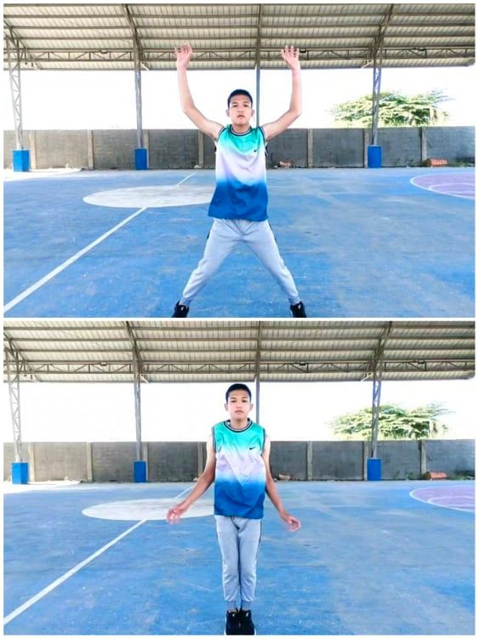

EX: JUMPING JACKS

**Meaning of Fine Motor Skills:**

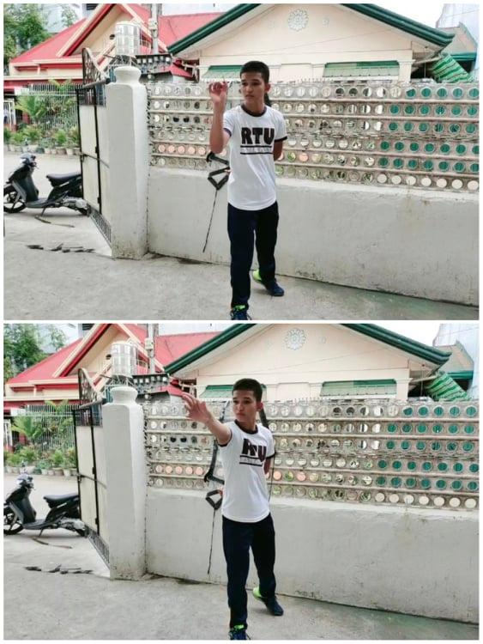It requires precision, as accuracy and control are crucial, and hence involves smaller muscle groups, most commonly the hands and fingers.

EX: DART THROWING

**Organization of the Skills**

Have a distinct beginning or end, and consist of a single distinct movement. As a result, students complete them relatively rapidly. Kicking, throwing, and hitting a ball are examples of discrete skills.

EX: THROWING A BALL

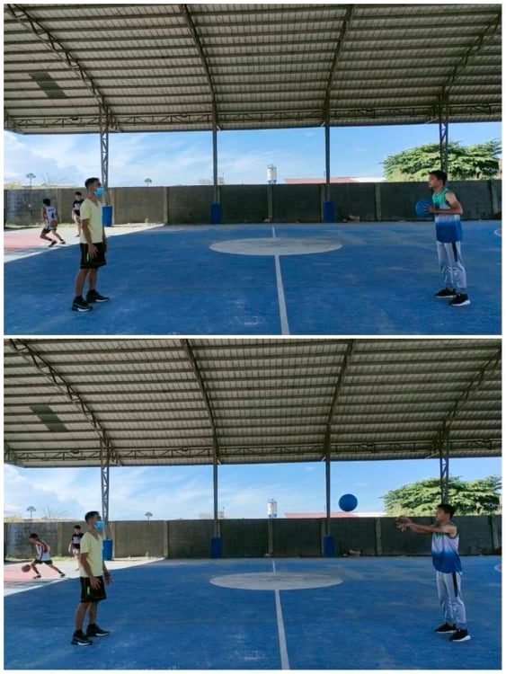

**Continuous Skill**

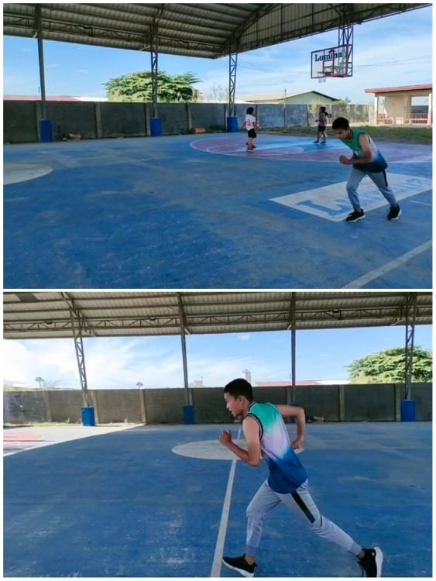There is no obvious beginning or finish to continuous skill. They last longer and include persistent and rhythmic movements. Running, cycling, and swimming are just a few examples.

EX: RUNNING

**Serial Skill**

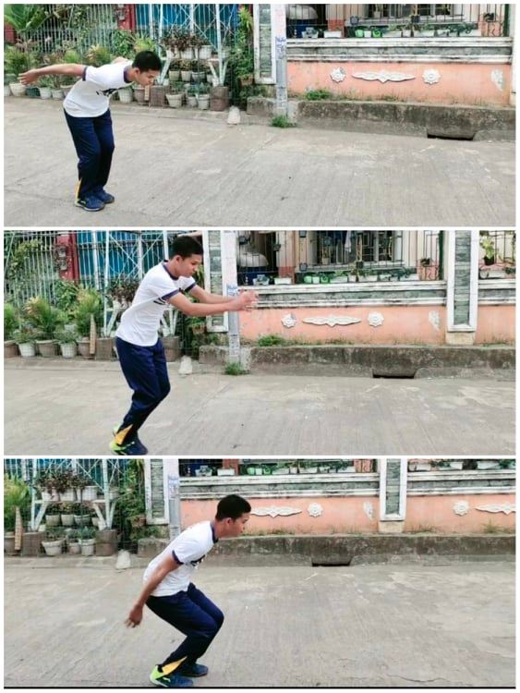A sequence of discrete talents connected together in a certain order is referred to as serial skill. The triple jump, a dancing routine, and pounding a nail are all examples of serial talents.

EX: TRIPLE JUMP

**Stability of the Environment**

**Closed Motor Skills**

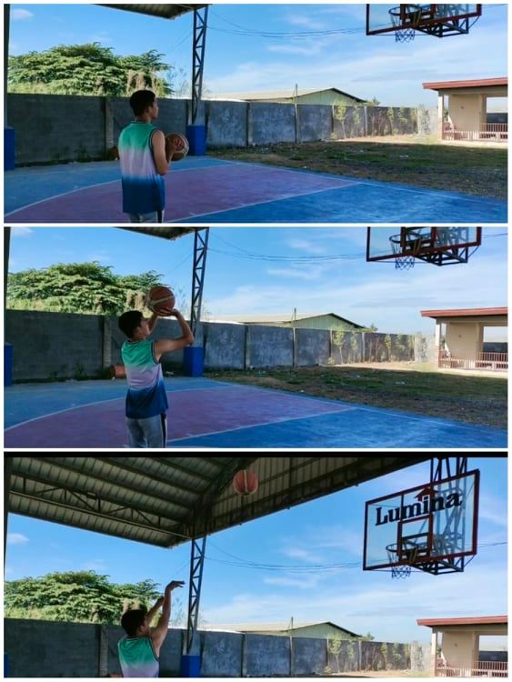Occurs in a controlled and predictable context. Because the performer chooses where to begin the action, it is referred to as self-paced. This means that the performer directs his or her actions toward the situation rather than reacting to it. Darts, basketball free throws, and high jump are just a few examples.

EX: BASKETBALL FREE THROW

**Open Motor Skill**

Occurs in an uncertain and changing setting, and the performer must react and adjust the skill to the circumstances. Since each skill's performance is unique, there are a lot of inertial variabilities also because the environment dictates the commencement of the movement, open motor abilities are externally timed. Passing in rugby, batting in cricket, and dribbling the ball in soccer are examples of open talents.

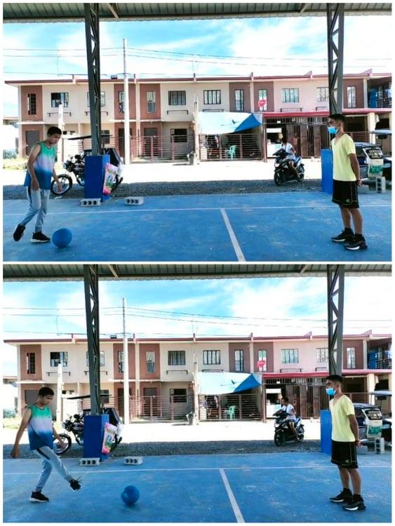

EX: SOCCER

**Limitations to the One-Dimensional Approach**

One-dimensional classification systems are useful for characterizing a skill so that we may better grasp the nature of the skill and explore how to best approach acquiring it. For example, in figure 2.1, one drawback is that because the feature is continuous, it can be difficult to categorize a skill into a single category. Another drawback is that they do not provide a complete picture of a skill's performance demand.

Closed

Open

Continuous

Discrete

Gross

Fine

**DART THROWING**

SWIMMING

Gross

Discrete

Closed

Fine

Continuous

Open

Figure 1

**Two-Dimensional Classification**

A two-dimensional classification method allows for more performance demands to be considered. Gentile (2000) describes two skill qualities: the environmental context and the action demand, in a two-dimensional taxonomy. The environmental context describes whether the regulatory conditions are stationary or moving, as well as the variability between trials. The action requirements specify whether the body's orientation shifts or whether an object is manipulated.

Environmental Context

Action Requirements

Regulatory Conditions

(Stationary or in motion)

Intertrial Variability

(Intertrial or no intertrial)

Body Orientation

(Body stability or transport)

Object Manipulation

(Manipulation or no manipulation)

Figure 2

**Regulatory Condition**

Are factors such as the size of the ball, the wind, the lighting, and the playing surface that influence how a learner performs a skill. When the environment is stable and does not fluctuate much during performance, this is referred to as a stationary regulatory condition. The dartboardboard, for example, keeps the same distance and height throughout the talent of dart throwing. The environment varies during a performance with an in-motion regulatory condition. In soccer, for example, a teammate's position can alter as you pass to them.

**Intertrial Variability**

Whether or not the performance requirements alter from one skill performance to the next. Kicking for a goal in sports, for example, necessitates kicking from different distances and angles each time.

**Figure 3: Example of skills in a two-dimensional skill classification approach**

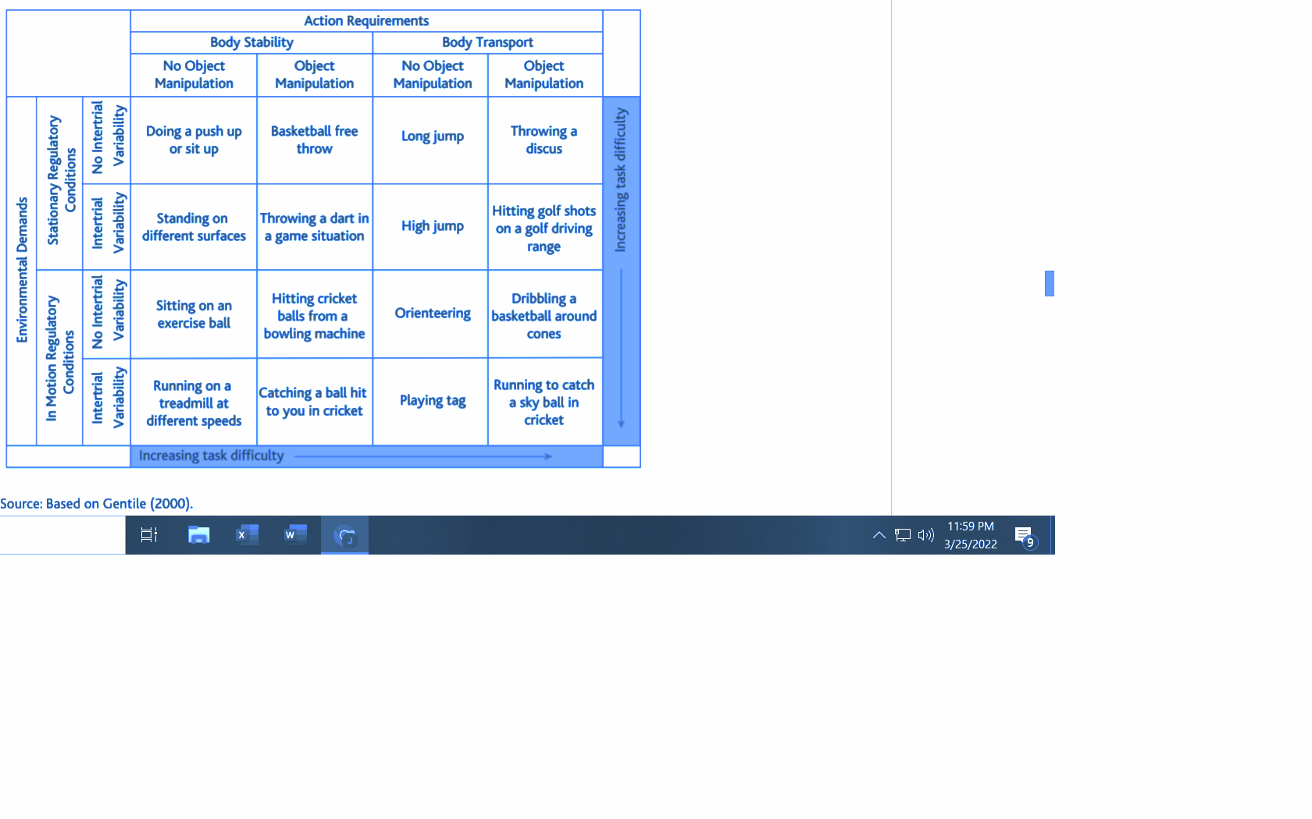

**MEANING OF VARIABLE SAMPLE SPORTS**

**Motor Learning In table tennis**

Table tennis is a game that can be played for the rest of one's life. Table tennis is beneficial to players of all ages. It's possibly the best sport for improving spatial visualization, which is crucial for future physical growth

The motor learning skills, refers to the brain's ability to gain control over the body's physically imposing system to make coordinated and timed actions in response to demands, are largely dominant in the sports we participate in. For many motor skills, such as table tennis, faster speed equals higher performance, as we can see while playing and learning the game, which features an exchange involving speed and precision while advancing toward a target. The motor skill in table tennis may also be seen in the required right movements and transformations that the motor system must learn. It also improves mental agility, reflexes, and brain activation in a unique 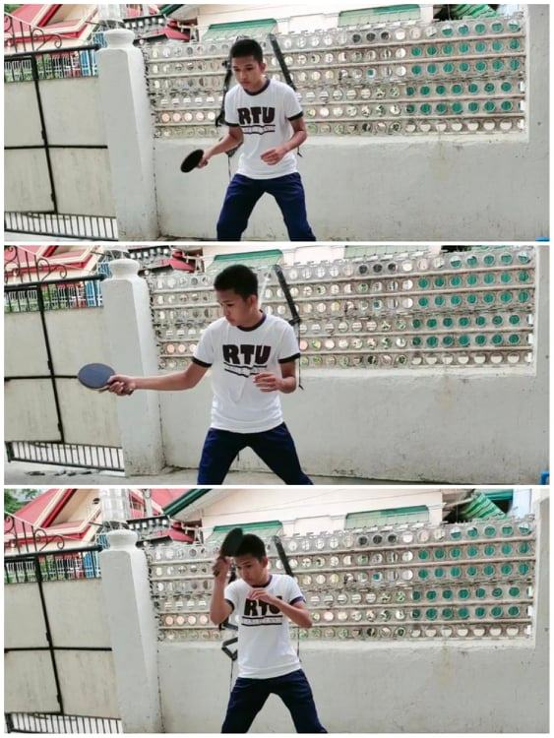way.

EX: REFLEXES TABLE TENNIS

**Motor learning in Basketball**

Basketball is a sport played by two teams of five-player groups competing on a rectangular court. Basketball is usually played indoors in leagues, although it is also frequently played outside in less structured "pick-up" games. The goal of the game is to throw (shot) a ball (known as the basketball) over the top of a circular band (known as the rim) with a cord hanging around its circumference (both referred to as the basket), which is attached to a backboard.

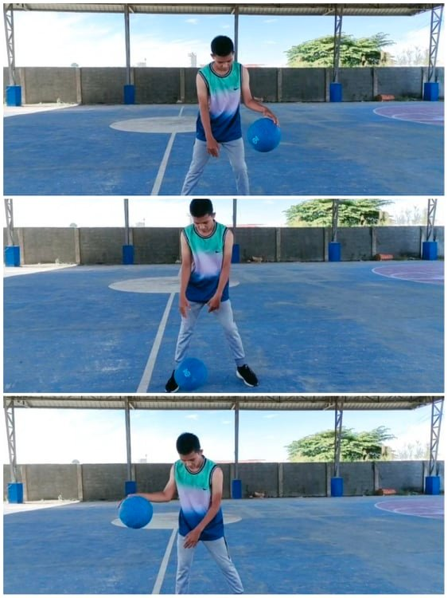Most basketball abilities require a combination of gross and fine motor skills to perform at a high level. Gross motor skills are demonstrated through the running movements as well as the arm action in dribbling. Furthermore, fine motor skills, such as the fingertips action in dribbling, are necessary to perform the activity.

EX: BASKETBALL DRIBBLING

**Motor Learning in Tennis**

Tennis is a racquet sport that can be played solo or in two-player teams with a single opponent. With a tennis racket strung with a cord, each player strikes a hollow rubber ball coated with felt into and over a net and into the opponent's court.

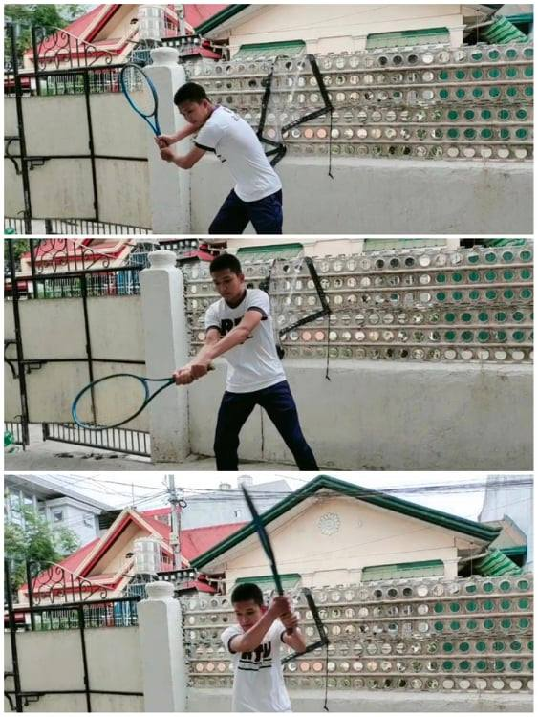Developing fine motor skills in tennis includes the touch shots like angled volleys, dropped shots, and lobs. On the other hand, controlling your vast muscle groups is also necessary for gross motor skills such as court mobility and ball-striking.

EX: TENNIS SMASH

**WATCH OR DOWNLOAD VIDEOS/PICTURES ON:**

**YOUTUBE:**

https://www.youtube.com/channel/UCnN-ar26sexOpWpQosoGvWw

**GOOGLE DRIVE:**

https://drive.google.com/drive/folders/1AGOw6xNfxDA45DO8HUdW5JbtZ18nwLGY?usp=sharing

**REFERENCES:**

Bailey, Armour, Kirk, Jess, Pickup, Sanford. (2009, February 17). The educational benefits claimed for Physical Education and school sport.

<https://www.tandfonline.com/doi/abs/10.1080/02671520701809817>

Gråstén & Watt. (2017, August). A Motivational Model of Physical Education and Links to Enjoyment, Knowledge, Performance, Total Physical Activity and Body Mass Index. <https://www.ncbi.nlm.nih.gov/pmc/articles/PMC5592282/?fbclid=IwAR2jTFLSmt9coVgOIRhOdHUn8tzzqy3UswrJD6YuFRGwr8SPlMxeD82a498>

Krakauer J., Hadjiosif A., Xu J., Wong A., Haith A., (2019, April 9). Motor Learning. https://www.researchgate.net/publication/331774116_Motor_Learning

McConkey R., Peng C., Merritt M., Shellard A. (2019, December 1). The Meaning of Social Inclusion to Players With and Without Intellectual Disability in Unified Sports Teams. <https://meridian.allenpress.com/inclusion/article-abstract/7/4/234/432674/The-Meaning-of-Social-Inclusion-to-Players-With>

Spittle (2021, March 3). Motor Learning and Skill Acquisition: Application for Physical Education and Sport. <https://books.google.com.ph/books?hl=en&lr=&id=zhlHEAAAQBAJ&oi=fnd&pg=PR5&dq=Motor%20Learning%20in%20Physical%20Education%20&ots=jc9CxZ5RdT&sig=FhltsPUEBKRf7yLKh2oNcrpa0aE&redir_esc=y#v=onepage&q&f=true>